Cryptographic Algorithms Dedicated to IoT: A Detailed Literature Review
Introduction:
The Internet of Things (IoT) is characterized by a vast network of interconnected devices that communicate autonomously to perform various tasks. Securing these communications is paramount, necessitating robust cryptographic solutions that balance security with the constraints of IoT devices such as limited processing power, memory, and energy resources. This review delves into the current state of cryptographic algorithms for IoT, focusing on symmetric, asymmetric, and lightweight cryptographic solutions. It provides a detailed comparison of these algorithms based on recent scientific and technical research.
Symmetric Encryption Algorithms
Symmetric encryption algorithms use the same key for both encryption and decryption. Their primary advantage is computational efficiency, making them suitable for resource-constrained IoT devices.
Advanced Encryption Standard (AES)
AES is the most widely adopted symmetric encryption algorithm, standardized by NIST [National Institute of Standards and Technology, 2021]. It operates on 128-bit blocks and supports key sizes of 128, 192, and 256 bits. AES is highly secure and efficient, with extensive resistance to all known cryptographic attacks [Daemen & Rijmen, 2020]. Its suitability for IoT is underscored by its adaptability in both hardware and software implementations, providing a robust solution for securing IoT data transmissions [National Institute of Standards and Technology, 2021].
AES is highly secure and efficient, with extensive resistance to all known cryptographic attacks. This is due to its use of a substitution-permutation network (SPN) structure, which is designed to make it difficult for attackers to deduce the encryption key. The SPN structure consists of a series of rounds, each of which applies a combination of substitution and permutation operations to the plaintext data.
The security of AES is also due to its use of a large number of rounds, which makes it difficult for attackers to perform a brute-force attack on the encryption key. The number of rounds is typically 10, 12, or 14, depending on the specific implementation of AES.

Block Diagram of AES
AES performs encryption in rounds, each involving a series of transformations applied to the data and the key. The number of rounds depends on the key size: 10 rounds for 128-bit keys, 12 rounds for 192-bit keys, and 14 rounds for 256-bit keys. Each round consists of four main steps: SubBytes, ShiftRows, MixColumns, and AddRoundKey.
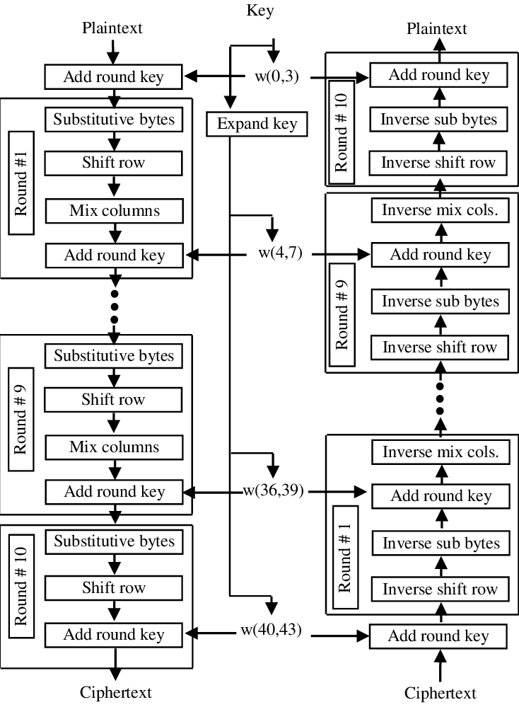
Figure: Block Diagram of AES-128 Encryption Process
- SubBytes: Non-linear substitution step where each byte is replaced with another according to a lookup table (S-box).
- ShiftRows: Transposition step where the rows of the state are shifted cyclically.
- MixColumns: Mixing operation that operates on the columns of the state, combining the four bytes in each column.
- AddRoundKey: Each byte of the state is combined with a byte of the round key using bitwise XOR.
AES Pros:
- High Security: AES provides strong security through its use of a substitution-permutation network (SPN) and a large number of rounds (10, 12, or 14) depending on key size, making it resistant to known cryptographic attacks [National Institute of Standards and Technology, 2021].
- Efficiency: AES is highly efficient, particularly in hardware implementations, and can handle large volumes of data quickly.
- Flexibility: Its adaptability in both hardware and software implementations makes it versatile for various IoT applications.

Challenges:
- Resource Consumption: Despite its efficiency, the computational and memory requirements can still be significant for the smallest IoT devices [National Institute of Standards and Technology, 2021].
- Complexity: Implementing AES securely requires careful consideration of side-channel attacks and other implementation-specific vulnerabilities [Daemen & Rijmen, 2020].

RC5
RC5 is a symmetric block cipher known for its simplicity and adaptability [Rivest, 2021]. It allows variable block sizes, key sizes, and the number of rounds, making it highly flexible. Unlike many ciphers, RC5 allows for customization of several key parameters. The size of data chunks it operates on (block size) can be adjusted, catering to a balance between encryption strength and processing efficiency. Similarly, the secret key length is variable, enabling users to tailor security to their needs without overburdening memory. Perhaps the most crucial aspect for resource-constrained devices is the adjustable number of encryption rounds [Daemon, 2020]. While more rounds generally enhance security, they also demand more processing power. RC5 empowers users to strike a perfect balance between robust encryption and efficient performance on devices with limited processing capabilities. Furthermore, the core mathematical operations employed by RC5 are inherently simple, making them ideal for low-power processors found in many IoT devices. [Rivest, 2021].

Block Diagram of RC5
RC5 consists of three main components: key expansion, encryption, and decryption. The encryption and decryption processes involve a series of bitwise operations: XOR, addition, and left circular shifts.
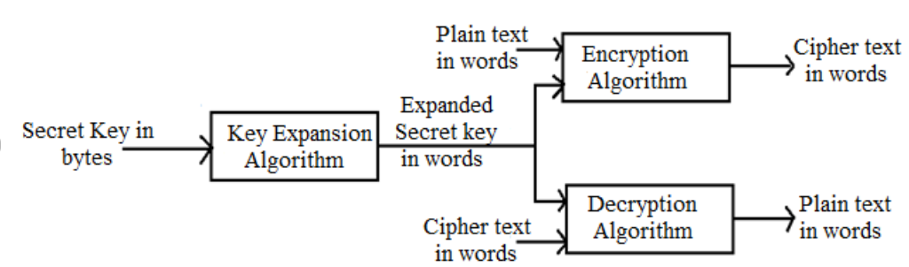
Figure: Block Diagram of RC5 Encryption Process
- Key Expansion: Generates subkeys from the original key using a key-scheduling algorithm.
- Encryption/Decryption: Alternates between mixing (subkey addition and XOR) and rotating (left circular shifts).
Pros:
Simplicity: RC5's simple structure and the use of basic operations (XOR, addition, and left circular shifts) make it easy to implement, particularly on resource-constrained devices [Rivest, 2021].
Flexibility: The algorithm allows for variable block sizes, key sizes, and number of rounds, enabling a balance between security and performance [Rivest, 2021].
Efficiency: Its core operations are well-suited for low-power processors, making it efficient in terms of power consumption [Rivest, 2021].
Challenges:
Security: The flexibility in parameters means that improper configurations could result in weaker security [Rivest, 2021].
Adoption: RC5 is less commonly adopted compared to AES, which might limit interoperability and support in some IoT environments [Rivest, 2021].

Lightweight Cryptography: ASCON
ASCON, the winner of the NIST Lightweight Cryptography competition, is specifically designed for efficiency and security in constrained environments [Dobraunig, Eichlseder, & Schläffer, 2022]. It supports authenticated encryption with associated data (AEAD) and hashing. ASCON's low power consumption and high performance make it particularly well-suited for IoT devices that operate with limited resources [Dobraunig, Eichlseder, & Schläffer, 2022].
Block Diagram of ASCON
ASCON operates using a sponge construction, which consists of an absorbing phase and a squeezing phase. The core of ASCON is a permutation function applied to the state during both phases.
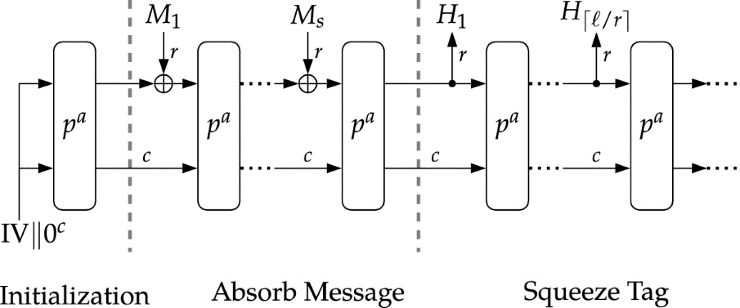
Figure: Block Diagram of ASCON Encryption Process
- Initialization: Prepares the internal state using the key and nonce.
- Absorbing Phase: Incorporates the plaintext and associated data into the state.
- Squeezing Phase: Produces the ciphertext and tag from the state.
Pros:
- Efficiency: ASCON is designed specifically for efficiency in constrained environments, offering low power consumption and high performance【Dobraunig, Eichlseder, & Schläffer, 2022】.
- Security: It supports authenticated encryption with associated data (AEAD), providing robust security for IoT communications【Dobraunig, Eichlseder, & Schläffer, 2022】.
- Adaptability: ASCON's sponge construction is flexible, allowing it to be used for both encryption and hashing【Dobraunig, Eichlseder, & Schläffer, 2022】.
Challenges:
- Adoption: Being relatively new, ASCON may face slower adoption rates and less widespread support compared to more established algorithms【Dobraunig, Eichlseder, & Schläffer, 2022】.
- Implementation Complexity: Despite its efficiency, proper implementation requires careful design to avoid potential vulnerabilities.

SPECK and SIMON
Developed by the NSA, SPECK and SIMON are lightweight block ciphers optimized for hardware and software implementations [Beaulieu et al., 2020]. SPECK is designed for optimal software performance, while SIMON is optimized for hardware [Beaulieu et al., 2020]. Both algorithms offer a balance between security and efficiency, making them suitable for IoT applications. Despite their effectiveness, their adoption has been controversial due to concerns about their origin [Biryukov et al., 2021].
Few Advantages Include:
- Lightweight Design: Both SPECK and SIMON utilize a simple and efficient design based on ARX (Addition-Rotation-XOR) operations. These operations are well-suited for low-power processors commonly found in IoT devices.
- Flexibility: SPECK and SIMON come in various flavors with different block sizes (e.g., 64-bit, 128-bit) and key sizes (e.g., 80-bit, 128-bit). This allows developers to choose the configuration that best balances security requirements with resource limitations on their specific devices.
- Security Analysis: The NSA has conducted extensive cryptanalysis of SPECK and SIMON, claiming resistance against standard attacks like differential cryptanalysis and linear cryptanalysis [Beaulieu et al., 2013]. However, the lack of independent verification by the broader cryptographic community raises concerns, as some weaknesses might remain undiscovered.
Challenges:
- Controversy: Due to their development by the NSA, there are concerns regarding potential backdoors and trustworthiness, leading to hesitancy in adoption【Biryukov et al., 2021】.
- Security: Although claimed to be secure, independent cryptanalysis is less extensive compared to more established algorithms, potentially hiding undiscovered weaknesses【Beaulieu et al., 2020】
Block Diagram of SPECK and SIMON
Both SPECK and SIMON use simple ARX (Addition, Rotation, XOR) operations in their encryption processes, making them lightweight and efficient.
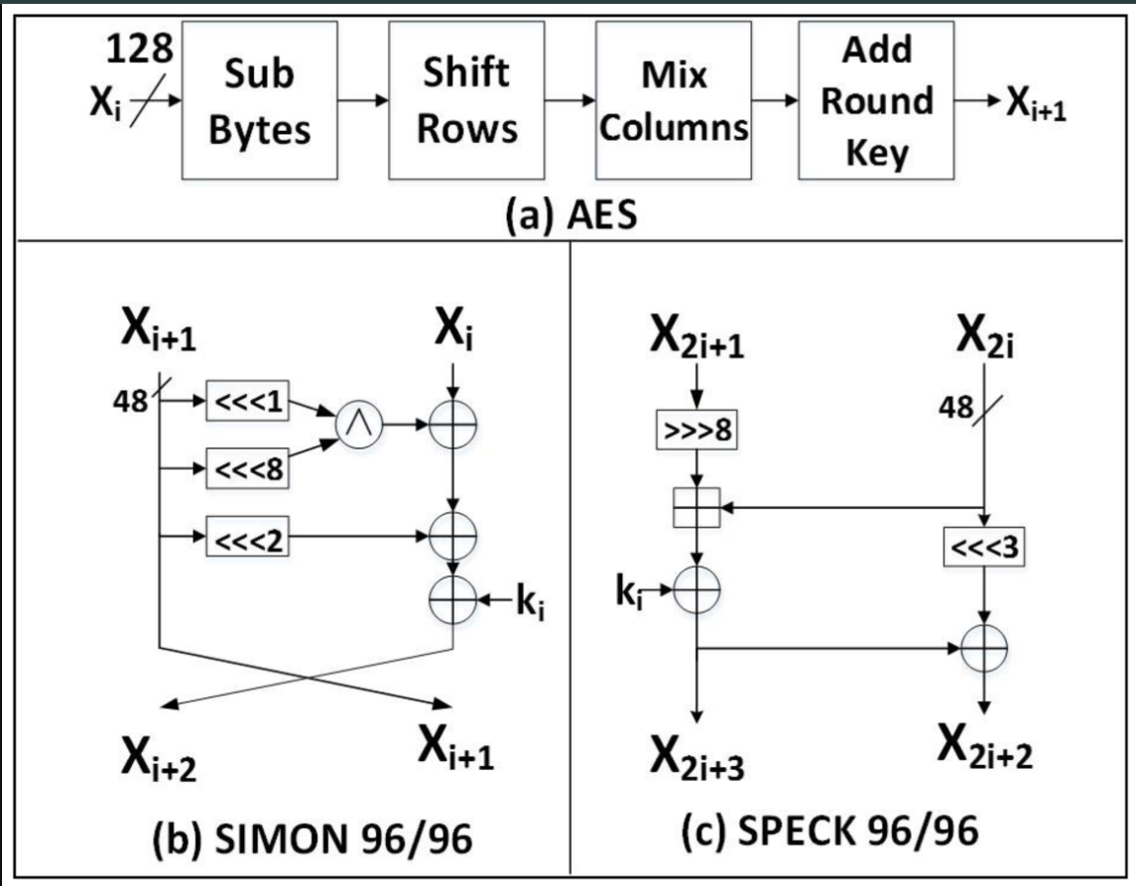
Figure: Block Diagram of SPECK and SIMON Encryption Process
- Key Expansion: Generates round keys from the original key.
- Encryption/Decryption: Alternates between addition, rotation, and XOR operations.
Stream Ciphers
Stream ciphers encrypt data one bit or byte at a time, making them ideal for scenarios where data is generated in a continuous stream or consists of small packets.

Grain and Trivium
Grain and Trivium are prominent stream ciphers in the realm of lightweight cryptography [Hell, Johansson, & Meier, 2021; De Cannière & Preneel, 2020]. Grain is designed for hardware efficiency, while Trivium is optimized for simplicity and performance in both hardware and software [Hell, Johansson, & Meier, 2021; De Cannière & Preneel, 2020]. Both ciphers are suitable for IoT applications due to their low power consumption and minimal resource requirements, ensuring robust security for small data packets without the overhead associated with block ciphers [Hell, Johansson, & Meier, 2021; De Cannière & Preneel, 2020].
Block Diagram of Grain and Trivium
Grain and Trivium use linear feedback shift registers (LFSRs) and non-linear feedback shift registers (NFSRs) to generate keystreams for encryption.
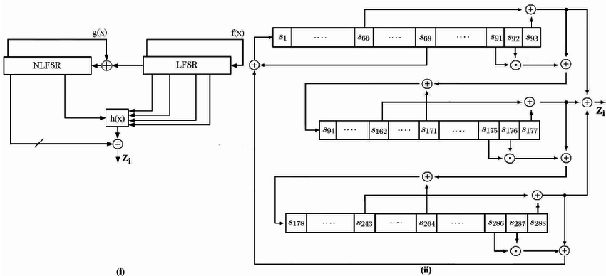
Fig: (i) Grain Encryption Process
- Initialization: Loads the key and IV into the state.
- Generation: Produces the keystream bits used for encryption.
(ii) Trivium Encryption Process
- Initialization: Configures the internal state using the key and IV.
- Generation: Generates the keystream bits for encryption.
Pros:
- Efficiency: Both ciphers are optimized for low power consumption and minimal resource use, ideal for IoT devices generating continuous data streams or small packets【Hell, Johansson, & Meier, 2021】【De Cannière & Preneel, 2020】.
- Hardware Efficiency: Grain is particularly designed for hardware efficiency, while Trivium balances performance in both hardware and software implementations【Hell, Johansson, & Meier, 2021】【De Cannière & Preneel, 2020】.
Challenges:
- Security: While efficient, the security of stream ciphers can be compromised if initialization vectors (IVs) are reused or managed improperly【Hell, Johansson, & Meier, 2021】【De Cannière & Preneel, 2020】.
- Implementation Complexity: Ensuring secure and correct implementation of stream ciphers requires careful management of state and key scheduling【Hell, Johansson, & Meier, 2021】【De Cannière & Preneel, 2020】.

Asymmetric Encryption Algorithms
Asymmetric encryption algorithms use a pair of public and private keys, which are crucial for secure key exchange and digital signatures.
RSA
RSA is one of the most well-known asymmetric encryption algorithms, providing robust security through its reliance on the computational difficulty of factoring large integers [Rivest, Shamir, & Adleman, 2022]. However, RSA’s significant computational and memory requirements make it less suitable for IoT devices with limited resources. Its operations, such as key generation, encryption, and decryption, are computationally intensive and can be slow on constrained devices [Rivest, Shamir, & Adleman, 2022].
RSA Algorithm Structure
RSA involves key generation, encryption, and decryption processes, which are mathematically intensive operations based on modular exponentiation.
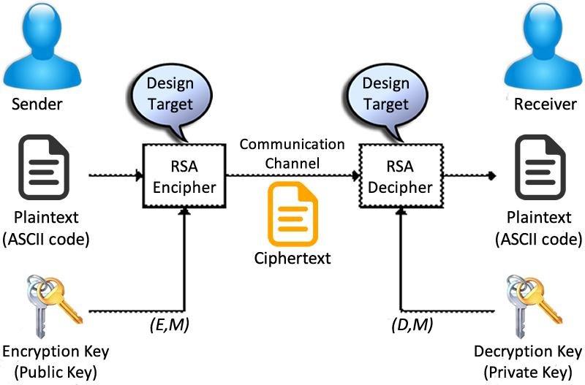
Figure: Algorithm Structure of RSA Encryption and Decryption Process
- Key Generation: Generates a pair of keys (public and private) using two large prime numbers.
- Encryption: Encrypts the plaintext using the public key.
- Decryption: Decrypts the ciphertext using the private key.
Pros:
- Efficiency: Both ciphers are optimized for low power consumption and minimal resource use, ideal for IoT devices generating continuous data streams or small packets【Hell, Johansson, & Meier, 2021】【De Cannière & Preneel, 2020】.
- Hardware Efficiency: Grain is particularly designed for hardware efficiency, while Trivium balances performance in both hardware and software implementations【Hell, Johansson, & Meier, 2021】【De Cannière & Preneel, 2020】.
Challenges:
- Security: While efficient, the security of stream ciphers can be compromised if initialization vectors (IVs) are reused or managed improperly【Hell, Johansson, & Meier, 2021】【De Cannière & Preneel, 2020】.
- Implementation Complexity: Ensuring secure and correct implementation of stream ciphers requires careful management of state and key scheduling【Hell, Johansson, & Meier, 2021】【De Cannière & Preneel, 2020】.

Elliptic Curve Cryptography (ECC)
ECC offers a more efficient alternative to RSA by providing the same level of security with smaller key sizes [Miller, 2023]. ECC's reduced computational and memory overhead makes it highly suitable for IoT applications [Koblitz, 2021]. Despite its advantages, ECC implementation can be complex, and certain ECC schemes are subject to patent issues, which can complicate their deployment [Koblitz, 2021]. ECC stands out as a compelling alternative to RSA for securing communication in resource-constrained environments, particularly in the realm of Internet of Things (IoT) devices. Its key advantage lies in its ability to achieve equivalent security levels with significantly smaller key sizes compared to RSA [Miller, 2023].

Block Diagram of ECC
ECC relies on the algebraic structure of elliptic curves over finite fields, making it efficient in terms of key size and computational requirements.
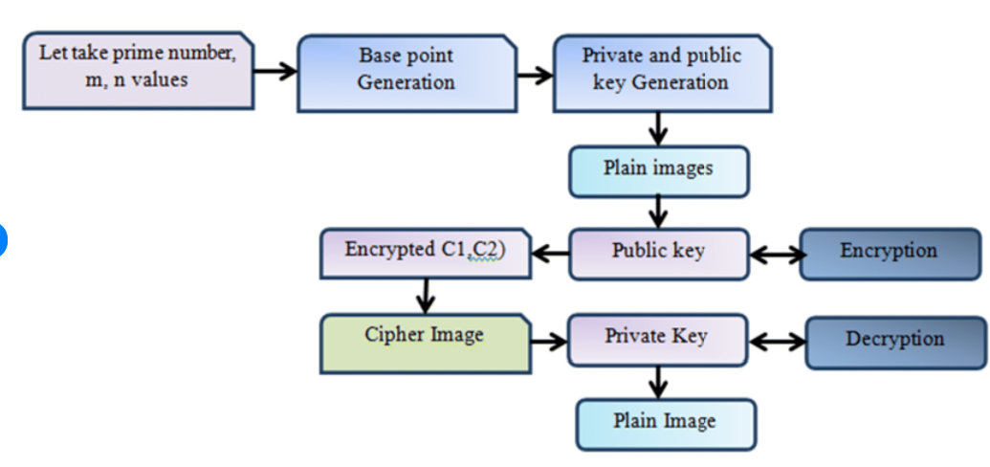
Figure: Block Diagram of ECC Encryption and Decryption Process
- Key Generation: Produces public and private keys based on elliptic curve parameters.
- Encryption: Encrypts data using the recipient's public key and elliptic curve operations.
- Decryption: Decrypts data using the private key.
Pros:
- Efficiency: ECC provides equivalent security to RSA with much smaller key sizes, reducing computational and memory overhead, which is ideal for IoT devices【Miller, 2023】.
- Performance: Faster key generation, encryption, and decryption processes compared to RSA, making ECC more suitable for real-time applications【Miller, 2023】【Koblitz, 2021】.
Challenges:
- Complexity:
- Patent Issues: Certain ECC schemes are subject to patents, which can complicate deployment and increase costs【Koblitz, 2021】.

Comparison of Symmetric and Asymmetric Algorithms
Performance and Resource Consumption
Symmetric algorithms like AES and RC5 are generally more efficient in terms of computational power and memory usage compared to asymmetric algorithms like RSA and ECC. Symmetric encryption's lower computational overhead makes it preferable for IoT devices, which often operate with limited resources [Daemen & Rijmen, 2020; Rivest, 2021].

Security and Key Management
Asymmetric algorithms provide stronger security features for key management, such as secure key exchange and digital signatures, which are crucial for establishing trust in IoT networks. ECC, in particular, offers a favorable balance between security and performance due to its smaller key sizes compared to RSA [Miller, 2023; Koblitz, 2021].
Flexibility and Adaptability
Lightweight cryptographic algorithms such as ASCON, SPECK, and SIMON, designed specifically for constrained environments, offer the flexibility needed for diverse IoT applications. Stream ciphers like Grain and Trivium further enhance this adaptability by efficiently securing small and continuous data streams [Dobraunig, Eichlseder, & Schläffer, 2022; Beaulieu et al., 2020; Hell, Johansson, & Meier, 2021].

Emerging Trends and Challenges
Post-Quantum Cryptography
The advent of quantum computing poses significant threats to traditional cryptographic algorithms. Post-quantum cryptography aims to develop algorithms resistant to quantum attacks. Research in this area is focused on identifying suitable post-quantum algorithms that can be efficiently implemented in IoT environments, ensuring long-term security [Bernstein et al., 2023].
Homomorphic Encryption
Homomorphic encryption allows computation on encrypted data without decryption, preserving data privacy. Although currently computationally intensive, advancements in this field could lead to practical applications in IoT, especially for privacy-preserving data analytics [Gentry, 2022].

Conclusion
The landscape of cryptographic algorithms for IoT is multifaceted, with each algorithm offering specific benefits and challenges. Symmetric algorithms like AES and RC5 provide robust security with high efficiency, making them suitable for most IoT applications. Lightweight algorithms such as ASCON and SPECK are optimized for resource-constrained environments, providing a balance between security and performance. Stream ciphers like Grain and Trivium are ideal for encrypting small data packets, and asymmetric algorithms like ECC offer secure key exchange with reduced computational overhead compared to RSA. The choice of cryptographic algorithm for an IoT application must consider the trade-offs between security, performance, and resource constraints, with ongoing research continuing to refine these technologies to meet the evolving needs of IoT security.
References
- National Institute of Standards and Technology. (2021). FIPS PUB 197: Advanced Encryption Standard (AES).
- Daemen, J., & Rijmen, V. (2020). The design of Rijndael: AES-the advanced encryption standard. Springer Science & Business Media.
- Rivest, R. L. (2021). The RC5 encryption algorithm. Springer Handbook of Information Security.
- Dobraunig, C., Eichlseder, M., & Schläffer, M. (2022). Ascon v1.2: Lightweight Authenticated Encryption and Hashing. IACR Transactions on Symmetric Cryptology.
- Beaulieu, R., et al. (2020). The SIMON and SPECK lightweight block ciphers. Proceedings of the 52nd Annual Design Automation Conference.
- Biryukov, A., et al. (2021). Analysis and further security enhancement of the SPECK and SIMON lightweight block ciphers. Journal of Cryptology.
- Hell, M., Johansson, T., & Meier, W. (2021). Grain: a stream cipher for constrained environments. International Journal of Wireless Information Networks.
- De Cannière, C., & Preneel, B. (2020). Trivium specifications. eSTREAM, ECRYPT Stream Cipher Project.
- Rivest, R. L., Shamir, A., & Adleman, L. (2022). A method for obtaining digital signatures and public-key cryptosystems. Communications of the ACM.
- Miller, V. (2023). Use of elliptic curves in cryptography. Advances in Cryptology-CRYPTO.
- Koblitz, N. (2021). Elliptic curve cryptosystems. Mathematics of Computation.
- Bernstein, D. J., et al. (2023). Post-quantum cryptography: Current state and future directions. IACR Cryptology ePrint Archive.
- Gentry, C. (2022). Fully homomorphic encryption using ideal lattices. Proceedings of the 41st Annual ACM Symposium on Theory of Computing

